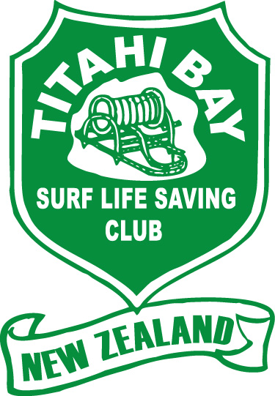

Titahi Bay Surf Lifesaving Club Inc

2018/19 COMMITTEE NOMINATION FORM

Name of person being nominated: ______________________________________________________________

Position:

President Chairperson

Treasurer Secretary

Club Captain Lifesaving Coordinator

Boat Captain Nippers Coordinator

Name of person making nomination: __________________________________________________________

Signature of person making nomination: _____________________________________________________

Seconded by; _______________________________________________________________________________________

Signature of seconder: ___________________________________________________________________________________

Nomination forms are to be received by the Secretary no later than 5pm
on Sunday 1 July 2018
Email: aboy@xtra.co.nz or post to: 5 Park Avenue, Titahi Bay

Margaret McDowell
Secretary

