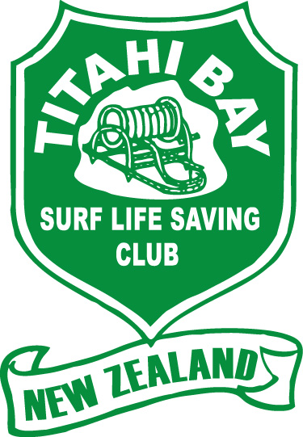

Titahi Bay Surf Lifesaving Club Inc

2020/21 COMMITTEE NOMINATION FORM

Name of person being nominated: ______________________________________________________________

Position:

President Chairperson

Treasurer Secretary

Club Captain Lifesaving Coordinator

Boat Captain Nippers Coordinator

Craft Coordinator

Name of person making nomination: __________________________________________________________

Signature of person making nomination: _____________________________________________________

Seconded by; _______________________________________________________________________________________

Signature of seconder: ___________________________________________________________________________________

Nomination forms are to be received by the Secretary no later than 5pm
on Sunday 19 July 2020
Email: jennamidd@hotmail.com or post to: 11 Bay Drive, Titahi Bay

Jenna Gopperth
Secretary
021 239 4355

